**District Workshop Scholarships**

The executive board of the Arkansas City Clerks, Recorders and Treasurers Association (ACCRTA) awards scholarships for members to attend district-level Institute Workshops, which enable Arkansas clerks to further their educational training and attain certification.

Completed scholarship applications should be returned to the ACCRTA Scholarship Committee chair:

Penny Lamb, CMC, CAMC, CMO

Recorder/Treasurer

City of Murfreesboro

805 N. Washington Ave.

Murfreesboro, AR 71958

Direct questions to 870-285-3732 work or 870-285-5000 cell or [murfreesboroclerk@yahoo.com](mailto:murfreesboroclerk@yahoo.com)Applicants must be city clerks, recorders, treasurers, deputy city clerks, or related titles at the time of application. Scholarships are available to all members. Preference is given to those within the district where the workshop is held, and who may not have participated previously due to budget constraints.

**Scholarships Available**:

$50.00 tuition-only scholarship

OR

$75.00 scholarship includes pre-class activities

OR

$175.00 scholarship to assist with expenses for participants traveling over 100 miles and requiring an overnight stay.

**2024 ACCRTA APPLICATION FOR DISTRICT WORKSHOP SCHOLARSHIP ASSISTANCE**

**DO NOT PREPAY FOR WORKSHIOP IF APPLYING FOR A SCHOLARSHIP!**

**DEADLINE**: 30 days prior to workshop start date

Name: ________________________________________ Title: _______________________________________

Mailing Address: _______________________________ Phone: ______________________________________

City, State, Zip: _________________________________ Email: ______________________________________

I am applying for District # _________ Workshop.

Workshop location: ________________________

Workshop dates: __________________________

*By signing below, I attest that I am a current member of* ***\*****ACCRTA. I understand that any scholarship awarded must be used for the purpose for which it was intended. I must attend all sessions and complete all assessments of the program for which I receive scholarship funds. I have attached written evidence that my chief executive or legislative body supports my attendance, and that if a scholarship is awarded, I will be given the time to attend. I attest that the information submitted with this application is true and correct to the best of my knowledge.*

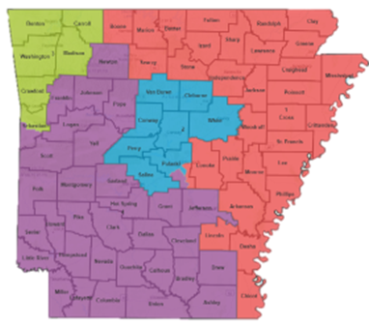

1

3

2

4

Signature: ___________________________________

Date: _______________________________________

**\***You must be a current member of the organization to receive scholarship funds. You may become a member at the time of application. However, your application will not be considered until membership is verified.

**Disclaimer: ACCRTA is not responsible for applications that do not reach the chairperson by**

**the deadline. Please feel free to call or email for verification of receipt.**

Municipality: ___________________________________

Date you assumed your present position: _____________

Education: H.S. Graduate ______ College Graduate (or years) ______ Degree ____________________________

Are you a member of ACCRTA?  yes, # of years ____  no

Have you received your CAMC designation?  yes  no

Are you a member of IIMC?  yes, # of years ____  no

Have you received your CMC designation?  yes  no

Have you received your MMC designation?  yes  no

Have you ever received a District Workshop Scholarship?  yes  no

If so, when was the last one received? ______________

How much does your municipality budget annually for your department for education? $________________________

Does your municipality pay or reimburse travel and meal expense?  yes  no

What is your approximate cost to attend the District Workshop (including tuition, lodging, meals and transportation): $________

What is your reason for applying for this scholarship? ____________________________________________________________________________________________________________________________________________________________________________________________________________________________________________________________________________________________________________________________________________________________________________________________